TIME PROBLEMS
KS1 – 2003 Paper 2
1.
KS1 – 2004 Paper 2
1.
KS1 – 2017 Paper – Reasoning
1.
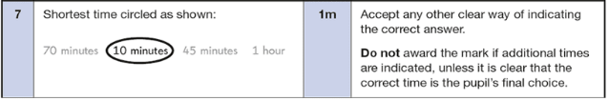
KS1 – 2018 Paper – Reasoning
1.
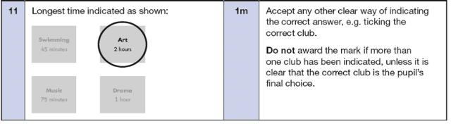
2.

